Spacecraft CyPhy Model

2/16/2016

Table of Contents

1 Introduction 1

2 Test Benches (TBs) 2

2.1 FEA_Shelf_2_Launch_Load 2

2.1.1 Current Status 2

2.1.2 Remaining Improvements 2

2.2 Mass_Properties 2

2.2.1 Current Status 2

2.2.2 Remaining Improvements 2

2.3 Gyroscope_Mass_Moment_of_Inertia 2

2.3.1 Current Status 2

2.3.2 Remaining Improvements 2

2.4 Distance_Between_Components 3

2.4.1 Current Status 3

2.4.2 Remaining Improvements 3

3 Issues 3

Revision History

|  |  |  |
| --- | --- | --- |
| **Date** | **Developer** | **Modifications** |
| 2/16/2016 | Robert O. | Initial Draft |
|  |  |  |
|  |  |  |

# Introduction

The Spacecraft CyPhy model was developed to demonstrate CyPhy capabilities applicable to spacecraft design. The target audience is JPL engineers.

This document describes the remaining work to complete the Test Benches.

# Test Benches (TBs)

## FEA_Shelf_2_Launch_Load

### Current Status

This TB:

1. Creates the assembly
2. Runs the FEA
3. Outputs stress plots.

Does not:

1. Create the ComputedValues.xml file, which would have the Factor-of-Safety and Von_Mises results. This may be due to an improper setup on Robert’s machine.

### Remaining Improvements

Determine why ComputedValues.xml is not created. Make the necessary corrections.

## Mass_Properties

### Current Status

This TB works correctly; however, Interference_Count may not be working for sub-assemblies.

### Remaining Improvements

Investigate if Interference_Count is working properly for all cases.

## Gyroscope_Mass_Moment_of_Inertia

### Current Status

This TB works correctly; however, a post-processing script must be written to compute the mass properties at the center of the gyroscope.

### Remaining Improvements

Develop a post processing script that:

1. Reads CADAssembly.xml to get the MetricID associated with the point at the center of the gyroscope.
2. Read ComputedValues.xml to get the coordinates of the center of the gyroscope. GYROSCOPE
3. Read the CADAssembly_metrics.xml to determine
4. The coordinates of the C.G. of the entire assembly
5. The mass moment of inertia tensor at the C.G.
6. Transform the inertia tensor to the center of the gyroscope. The equation/function “def parallel_axis(Ic, m, d)” is shown at <http://pydoc.net/Python/yeadon/0.95/yeadon.inertia/>

## Distance_Between_Components

### Current Status

This TB works correctly; however, a post-processing script is needed to compute the distances between points (i.e. batteries, computers, and gyroscope).

### Remaining Improvements

Develop a post processing script that:

1. Reads CADAssembly.xml to get the MetricIDs associated with the points at the center of the batteries, computers, and gyroscope.
2. Read ComputedValues.xml to get the coordinates of the center of the batteries, computers, and gyroscope.
3. Compute the distances between the points.

# Issues

The density units in the Creo models are in kg/mm^3. The units for the FEA model should be as shown in yellow in the following table. The units should be t/mm^3. t (tonne) = 1000 kg.

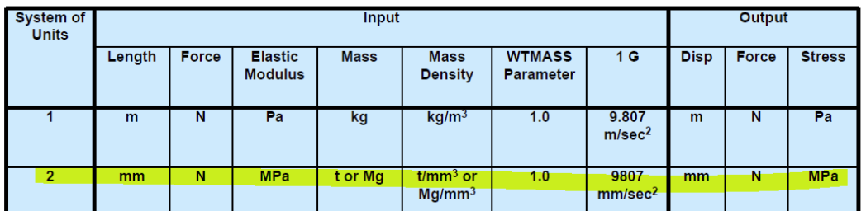

To correct the FEA TB for now, the acceleration value was divided by 1000 so that F = ma would result in the correct load. This will work for an acceleration load, but not for modal analysis.

On possible approach to handling this properly would be for the CreateAssembly program to adjust units such that they adhere to a standard (e.g. rows 1 or 2 in the above table).